Lesson 3 Assignment

Student’s Name
Institutional Affiliation
Course Code and Name
Instructor’s Name
Date

Lesson 3 Assignment
Vi
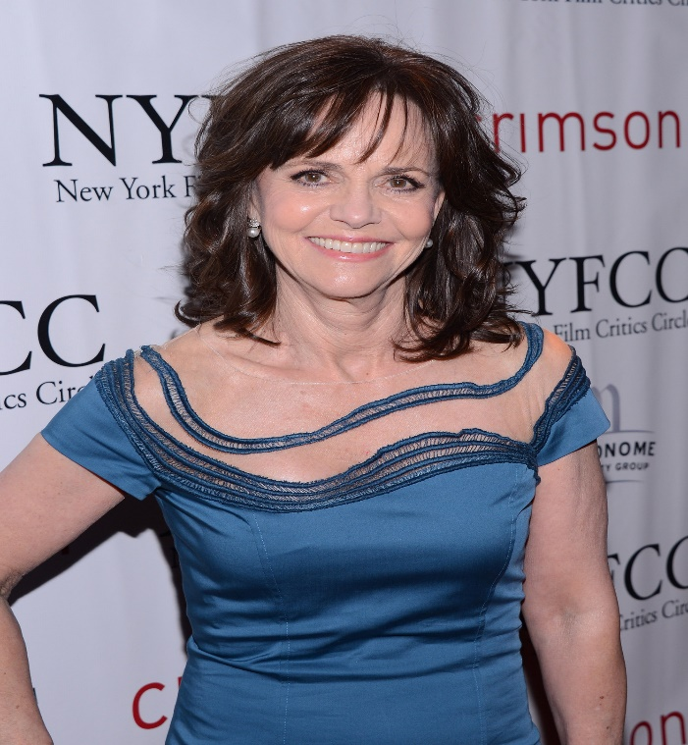
Vi's character in “Come and go” film should is portrayed as the main character where she enters and exits the stage on several occasions. She plays the parts of a diverse character. Being diverse, Vi should be an assistant director (Beckett, 2021). Vi suites the aforementioned role since she will help in checking various directing considerations during the play.
Flo
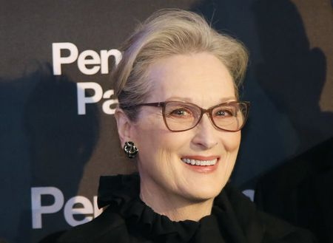
Flo plays a significant role in the “Come and go” film, and she suites the role of the director of photography. Moreover, I selected Flo since she appears to be a creative character and the director of photography; she will ensure that the film adopts a unique and attractive outlook.
Ru

Ru's character best suits the role of script supervisor. As the script supervisor, Ru will ensure that each character effectively adheres to the script’s content without alteration (Beckett, 2009). The primary reason I selected Ru as the script director is based on her conciseness during communication. She appears to be an individual who effectively follows instructions.

Reference
Beckett, S. (2021). Come and Go. Journal of Beckett Studies, 29(1), 120-122.
Beckett, S. (2021). Come and Go (con sottotitoli in italiano). https://www.youtube.com/watch?v=lecqhCWyrqE
.

